## 

**My Experience User console**

**Overview, Build & Maintenance Manual**

**Change Log:**

|  |  |  |  |
| --- | --- | --- | --- |
| **Version** | **Date** | **Updated By** | **Notes** |
| 1.0 | 28/05/2018 | Javad Adeli | Initial Release |
|  |  |  |  |
|  |  |  |  |
|  |  |  |  |

# Table of contents

Overview of My Experience User Console 4

Note: 4

Accessing My Experience User Console 5

Viewing information 5

Changing a Current Position 5

Note: 5

Changing the Default Organizer View 6

Build and Maintenance 8

Building Role types 8

Important Note 8

Adding Positions to existing Role Types 8

Adding new role type 9

Configuring Position level and User level access for the role types 10

Assigning User Level Role types to Users 13

Combining User Level and Position Level access for a User 14

Important Note: 14

# Overview of My Experience User Console

The My Experience User Console allows you to change your position, default organizer view in PowerChart and FirstNet. This is designed for clinicians, whose work crosses multiple specialties and therefore need to change their position on a regular basis, allowing you to change your view on your own.

#### ***Note:***

Ensure that My Experience is not used to switch among positions with different security and privileging, as a number of services cache privilege information and need to update your cache in order for the full effects of the position change to be experienced. The time interval for caching servers, such as 357 for privileges and 50 for task security access, depends on domain setup. This same logic holds true when switching a user’s position using HNAUser. For this reason, Cerner recommends the use of a hybrid position for these types of users.

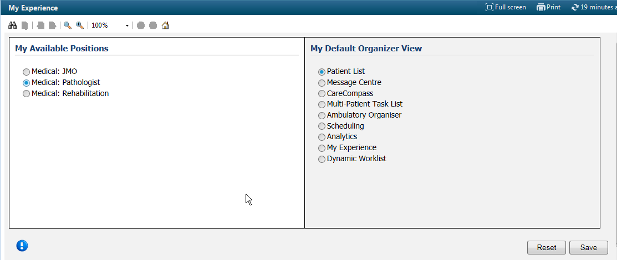

# Accessing My Experience User Console

To access My Experience User Console from *PowerChart* or *FirstNet* click **My Experience** or select **My Experience** from the View menu on the *PowerChart* menu bar.



#### Viewing information

To view information about the My Experience User Console click the blue information button.

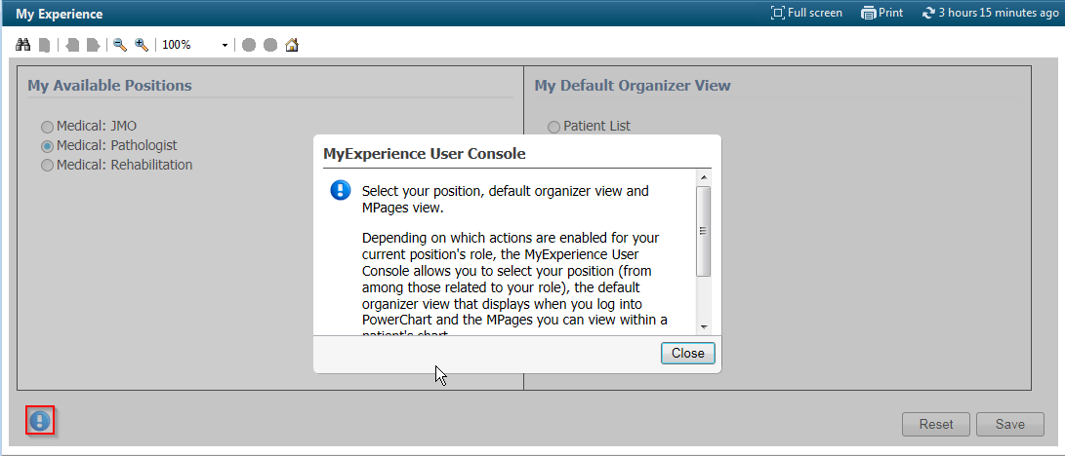

#### Changing a Current Position

Complete the following steps to change your current position:

1. From the My Experience User Console under the My Available Positions column, select the position you want to move to from the Positions list.

#### ***Note:***

The Positions list is determined eMR Application/Security managers.

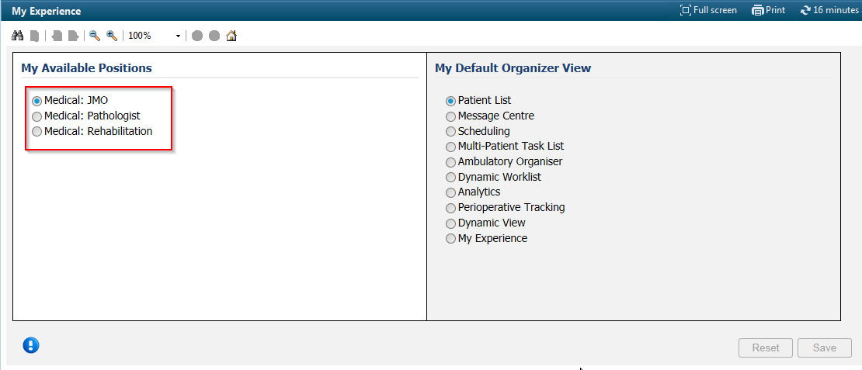

1. Click Save to save your changes or click Reset to revert to the last saved settings. To change positions, you must log out and then back in to PowerChart. If you click Save, a dialog box asks if you are ready to log out. If you select Log Out, you are immediately prompted to log back in.

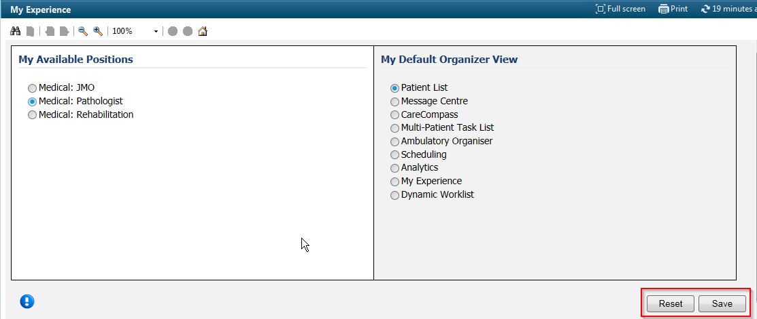

#### Changing the Default Organizer View

Complete the following steps to change the default organizer view:

1. From the My Experience User Console under the My Default Organizer View column, select the default organizer view you want to see when you open PowerChart.

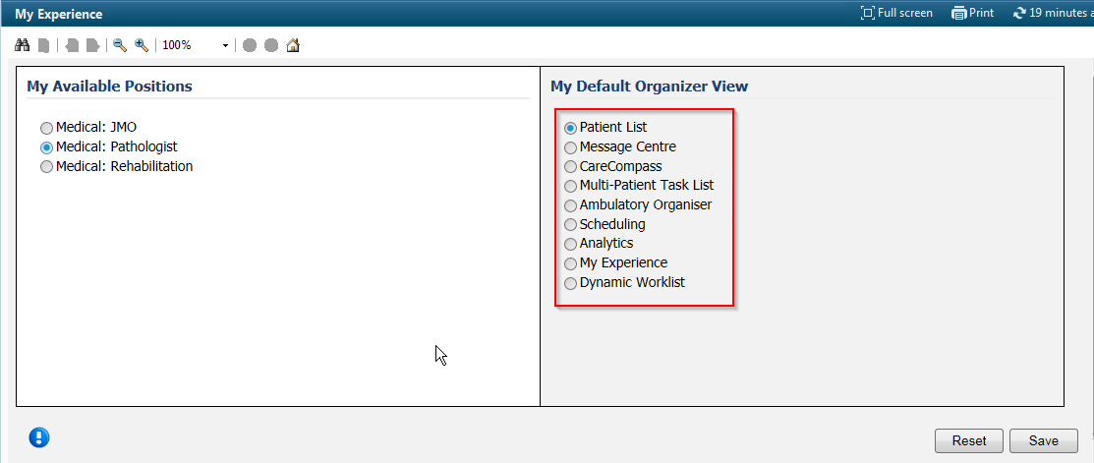

1. Click **Save** to save your changes or click **Reset** to revert to the last saved settings.

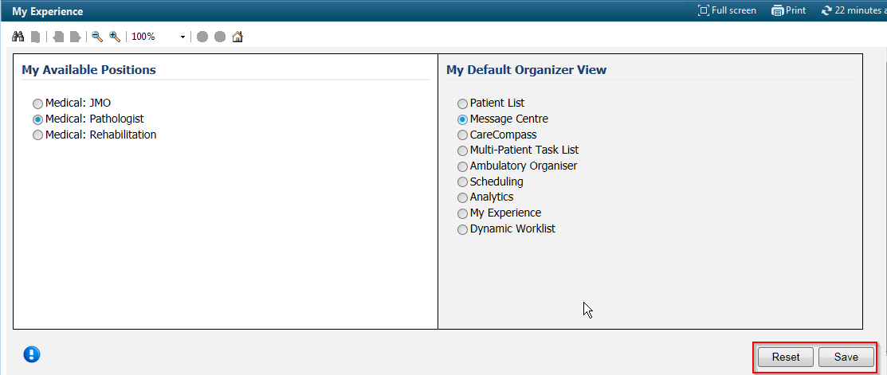

# Build and Maintenance

#### Managing Role types

To use My Experience user Console we need to define and build role types and include required positions within each role and decide if these role types are going to be configured and used at the position level or User level.

If a role type is applied at a position level, every user in the positions within those role can switch position, while if the role is defined at the user level, only users that have been granted access to the role will be able to switch positions.

#### Important Note

Make sure all the positions included in a role type have access to the My Experience page in their organiser menu bar to switch their positions back.

#### Adding Positions to existing Role Types

For each group of users who you want to enable to switch among a different set of positions, ensure that you have a role to encompass the position or positions of those users (if configuring My Experience on the position level) or the individual users (if configuring My Experience on the user level). Identify the existing roles that are appropriate for your group. If needed, add new role type for all the roles you need.

1. In User Maintenance, from the Task menu, select**Maintain > Role Types**.
2. In the Role Type Management box, select the role identified for the group of users.
3. Click the **Advanced** tab to view the Related Positions list for that role
4. Click on New icon  to add all positions the group of users needs to see to the My Available Positions list. You can click **Name** to alphabetize the list of positions.
5. Click **Ok** and then **Apply** to save changes

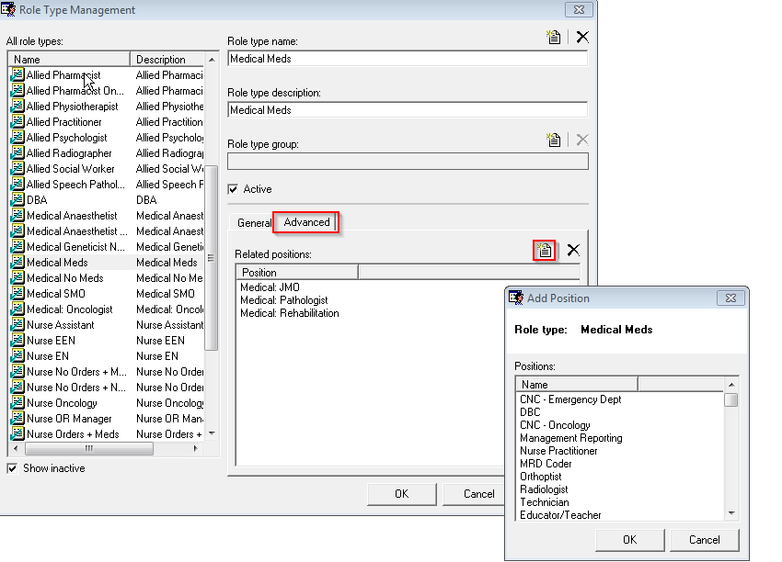

#### Adding new role type

If the positions that need to be switched are not defined in any existing role types, you need to build a new role type and include the required positions in the role.

1. In User Maintenance, from the Task menu, select**Maintain > Role Types**.
2. From the top right corner click on the new icon  to add a new role type by completing the role name and description

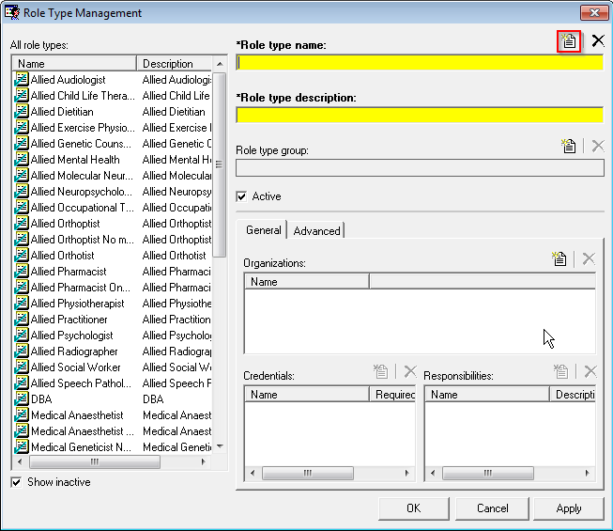

1. Click the **Advanced** tab to add Related Positions list for that role
2. Click on New icon  to add all positions the group of users needs to see to the My Available Positions list. You can click **Name** to alphabetize the list of positions. (Code Set 343575)
3. (Only if adding the New role type as User level) – Click on **General** tab, and then click on new icon  to add at list one organisation.

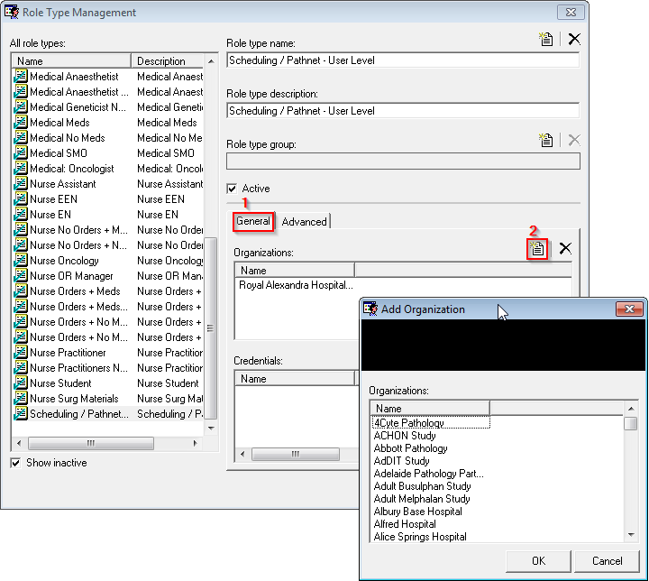

#### Configuring Position level and User level access for the role types

Role types are defined in Code Set 343575 (using Roe Type management in HNAUser). Adding new role types will create a new row in Code Set 343575.

We use Configuration manager tool (configurationmanager.exe) to manage access level in my Experience user console.

1. Run configuration manager tool
2. Click on MyExperience Admin Console

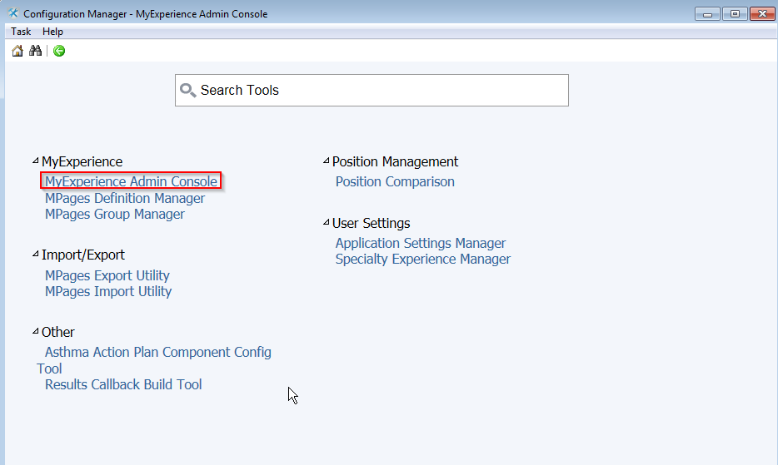

1. From the Console you will see all the existing role types under **Role.** Under **My Available Positions** select if you want the role type to be On at Position Level or on at User level only (use can select Off if the role is not going to be used).

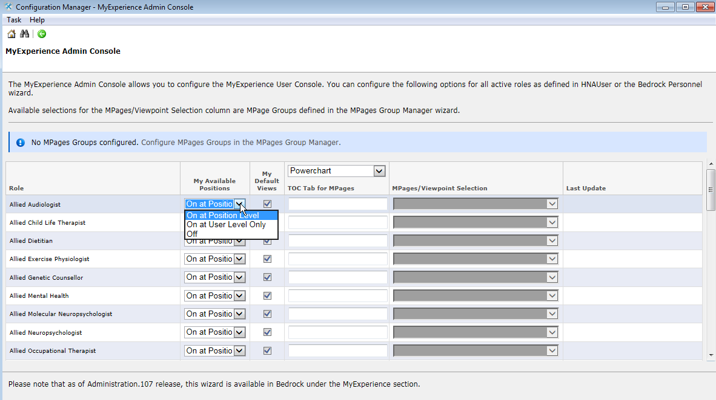

1. Under **My Default Views** column tick the checkboxes to display the list of default organiser views for the positions in the MY Experience user console.

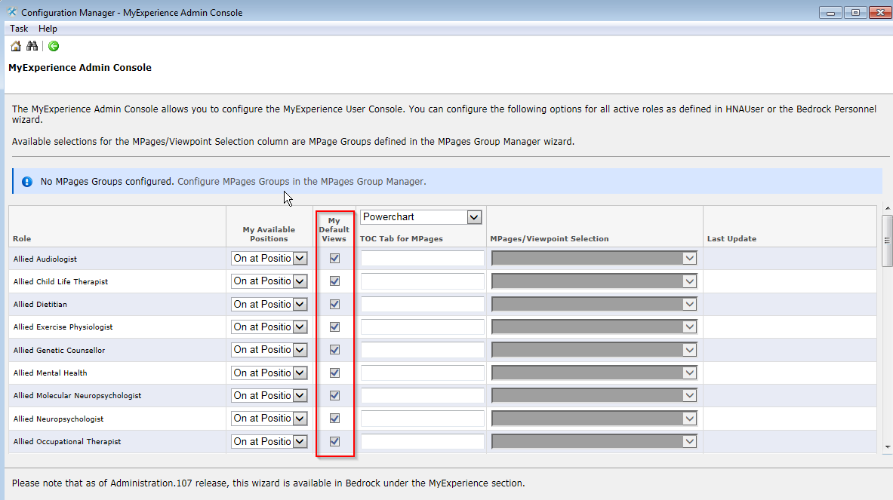

1. After completing the changes, click **Save** button to save your changes

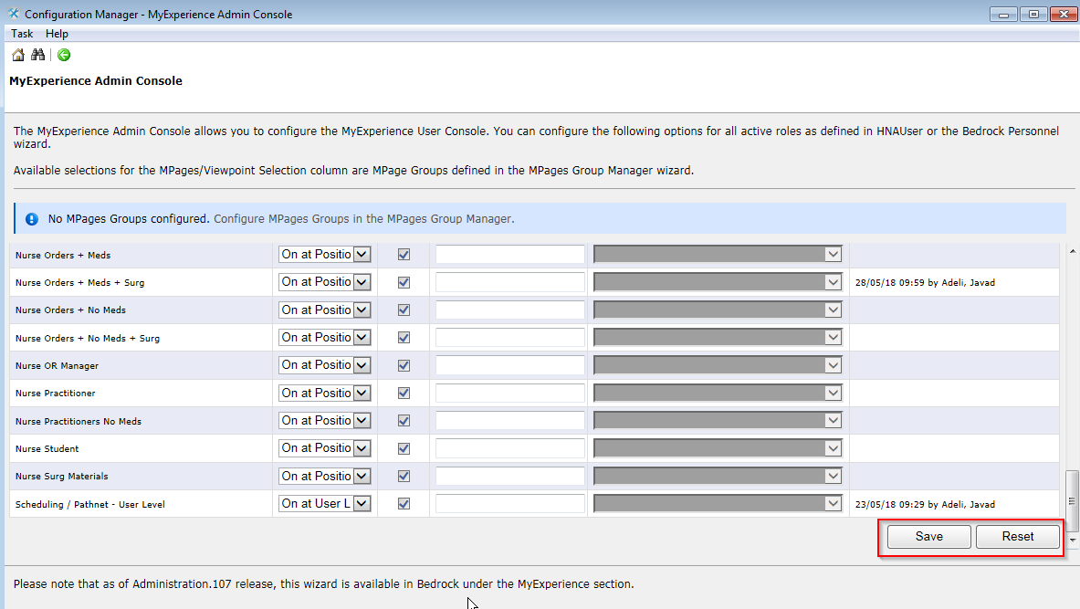

#### Assigning User Level Role types to Users

If you want to give only some users access to a role type to switch between positions available for that role, you need to grant them access to the role.

1. Open **HNAUser** tool and find the user
2. Right click on the user’s name and select **Prsnl Role Types…**

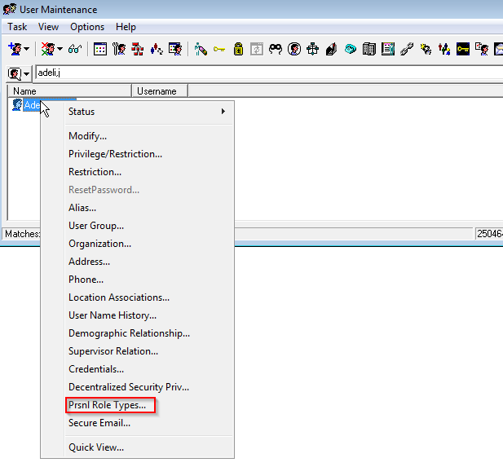

1. Click on the **New** icon  to assign the role type to the personnel

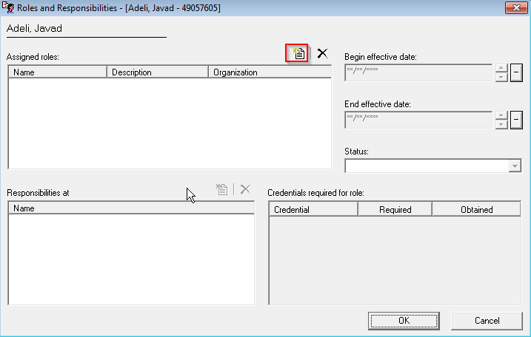

1. You should see the list of all the roles types that have been configured at User level in **configurationmanager** tool. Tick the checkbox against the required role type to assign it to the user

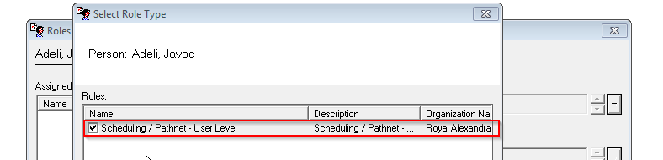

#### Combining User Level and Position Level access for a User

If a user has user level roles assigned to him/her and that user’s position also have access to a position level role type, the user will have access to all the positions available for the user level and the position level role types.

If this user at the position level changes his/her position to a position that is only available on the user level and not his/her current position, he/she would not be able to switch back to that position, as it is not available at the user level.

So it is always good practice to carefully design role types and separate positions in each role type and only create user level role type if needed an also suspend or put end date on users if they only have a temporary hybrid role.

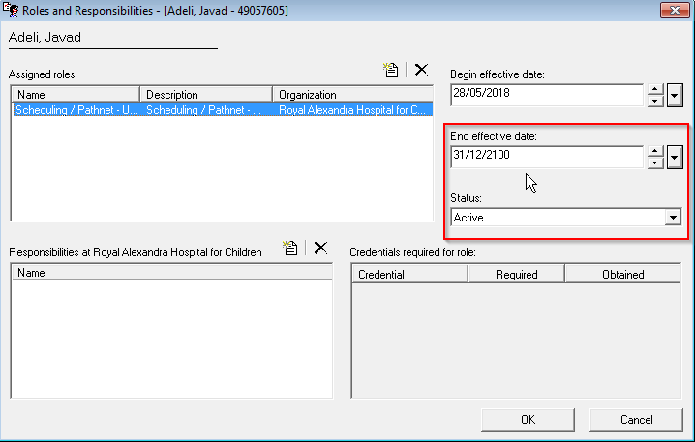

#### Important Note:

Make sure all the positions included in a role type have access to the **My Experience** page in their organiser menu bar to switch their positions back.